Newly Committed Fleets
Climate Mayors EV Purchasing Collaborative Social Toolkit

As a newly committed fleet, we need your help to both promote your organization’s leadership and to expand the reach and impact of the purchasing collaborative via various social media platforms. Below, you’ll find sample content for your consideration.
Please tag @ClimateMayors and @ElectricRoadmap, and use the #ClimateMayors or #DriveEVFleets
Hashtags so we can amplify your message.

Thank you in advance!

+++

Membership Graphic

The below graphic can be used on social media, in newsletters, blogs, flyers, on your website, or in email signatures as you see fit!
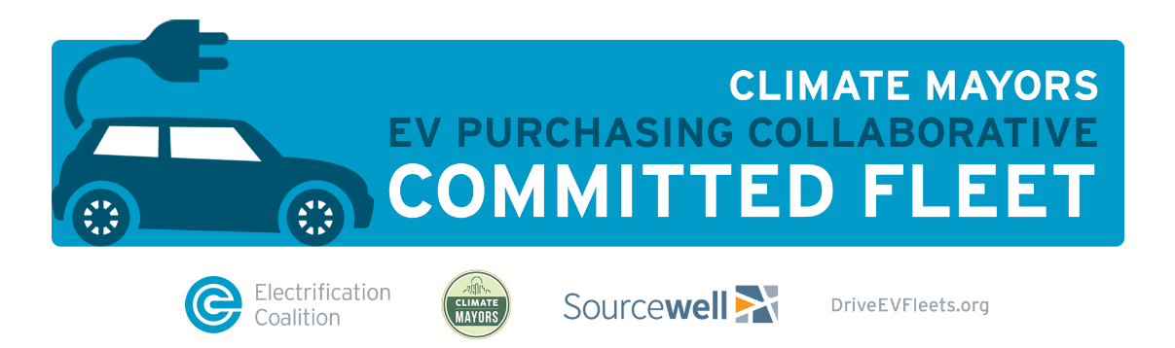

Social Media Content

- (enter entity name) is excited to be part of the @ClimateMayors #EV Purchasing Collaborative, working with over 200 public fleets to purchase electric vehicles. Together we can advance the future of transportation through electrification. @ElectricRoadmap #DriveEVFleets
- We've joined 210+ fleets by committing to add more EVs by the end of 2021. Through @ClimateMayors EV Purchasing Collaborative, we’re changing the future of transportation by unlocking the many benefits of #EVs. http://DriveEVFleets.org #DriveEVFleets @ElectricRoadmap
- The @ClimateMayors #EV Purchasing Collaborative is changing the future of transportation by illustrating the economic, environmental, and social benefits of purchasing #EVs. We at (enter city name), are proud to be a Collaborative committed city! #DriveEVFleets @ElectricRoadmap

Newsletter content: The EC is also available to draft content for any newsletter, blog, or other article drafting.

The Climate Mayors EV Purchasing Collaborative was launched in Fall 2018 with the help of the Electrification Coalition to leverage the buying power of fleets to make electrification simple, affordable, and accessible. The Collaborative works with over 210 fleets around the nation to highlight those who are transitioning their fleets to electric.

The goal of the Collaborative is to support fleet electrification efforts by providing free and customized technical support and procurement help, as well as helping fleets identify funding for vehicles and charging stations.

Our fleet has made a new procurement commitment of ___ EVs in the next (entire time frame). This commitment comes in coordination with the city’s sustainability plan, which aims to transition transportation sources to be more sustainable.

By making commitments through the Climate Mayors EV Purchasing Collaborative, the city is committed to local action on undertaking climate action by electrifying transportation, making infrastructure efficient and growing our economy through investing in the sectors that enable a climate-compatible future. This new committed marks the first of many steps towards furthering the city’s investment in a sustainable future.

Logos for use with announcement:
In addition to the social media posts, op-eds, or press releases that are all helpful in highlighting your city’s new commitment, here are some additional logos that can be used to bring awareness to the Collaborative and the organizations that help organize it.

Case Study content:

It is important to highlight the accomplishments and progress being made of our member cities through Case Studies. Each Case Study provides information about the new commitment made by a particular fleet and highlights the fleet improvements the city has made within the last year or so. Example Case Study topics include newly implemented charging system infrastructures, newly committed EV procurements, or a combined overlook of both of these topics over a specific time frame.

In each Case Study, we like to use pictures from each city that include charging stations (if already installed) or any new EVs (if already delivered). This helps give readers of the Case Study a good physical representation of the commitment to go along with the description of the entity’s initiative.

Please reach out to if you’d like to work on a case study together! You can find our completed ones here: https://driveevfleets.org/media/

